C PROGRAMMING TO REVERSE A GIVEN NUMBER

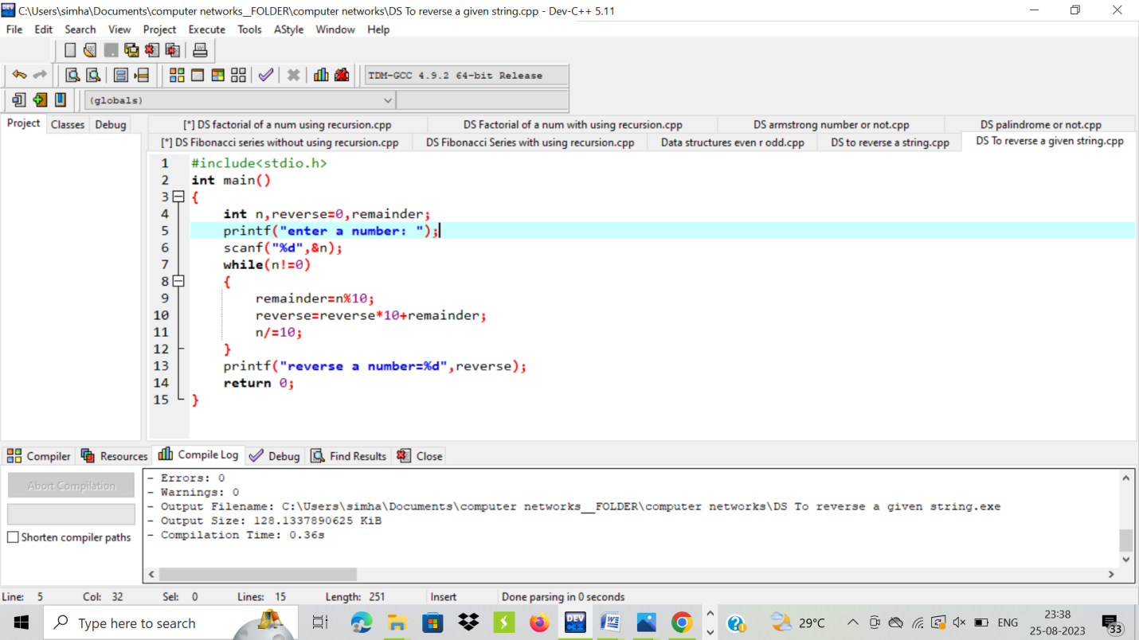

OUTPUT:

